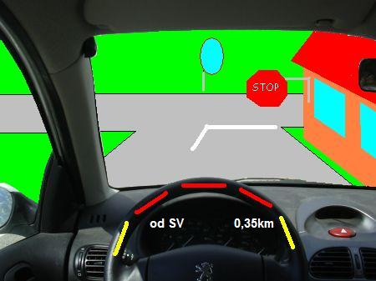
NAVIGATION RALLY (winter 2007)

For whom?
For everyone (prepared on the level of CP/ MP Cup but do not worry everyone can take a challenge)
Date?
8.12.-31.12.2007
Place?
„v Jemništi“ (CZ)
Organizers?
route planner: Janek Prošek, HR (main referee) : Petr Mašek
Route?
Jemniště, Křemení, Dobříčkov, Roubíčkova Lhota, Lísek, Postupice, Pozov, Moklíny

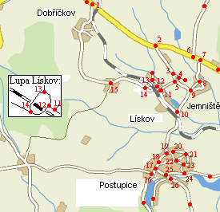
Organizers of the rally declare that every part / section of a route is prepared due to the official ASO regulations and that participants will be treated on equal terms. So help us God!
We invite everyone to take a challange and have a fun with us!

Everything will happen on-line. More details – soon.

