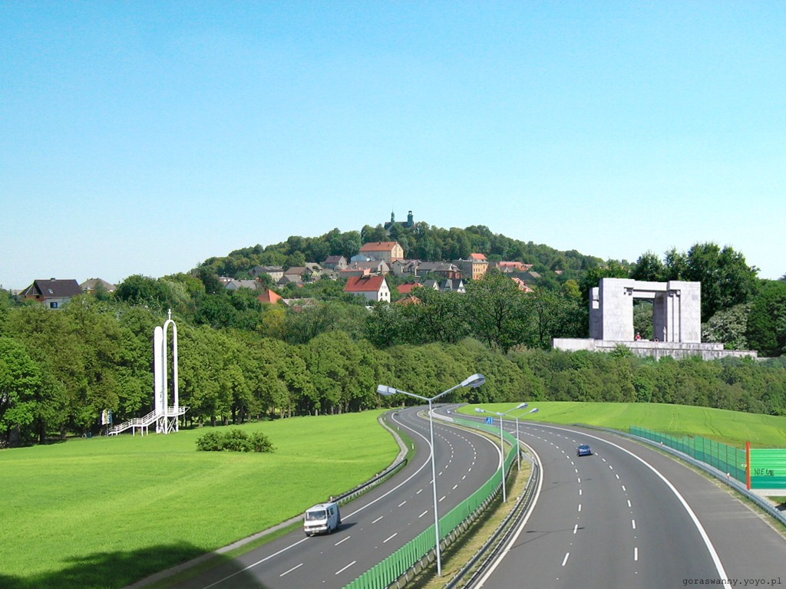
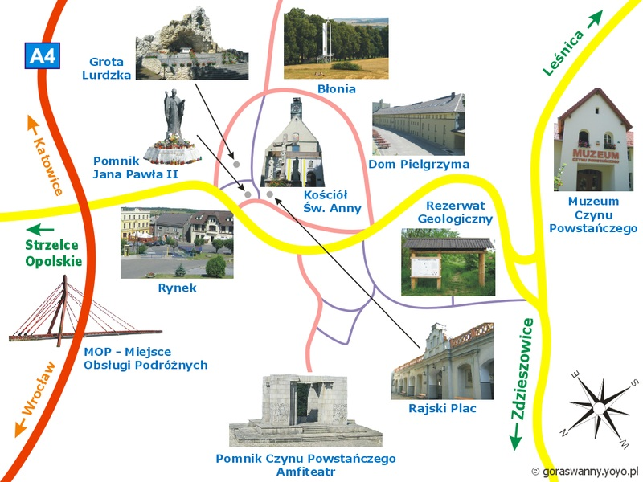
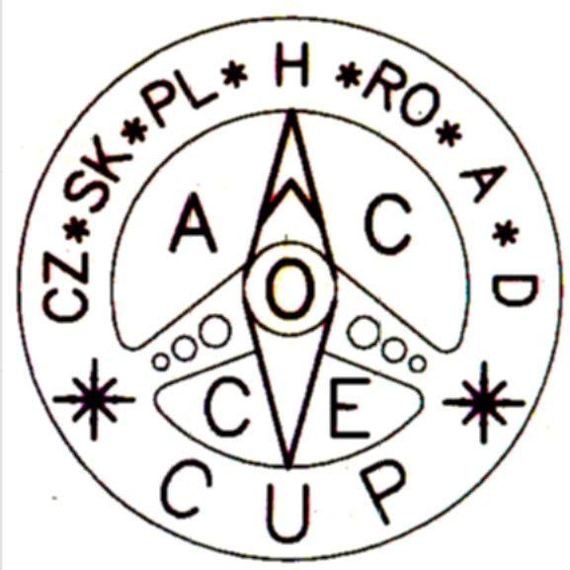

Zarząd Okręgowy PZM
w Opolu

Opolskie Stowarzyszenie
Automobilistów

Navigation Rally

KARLIK ‘ 2 0 1 0

Góra Św.Anny, August 6th -8th, 2010

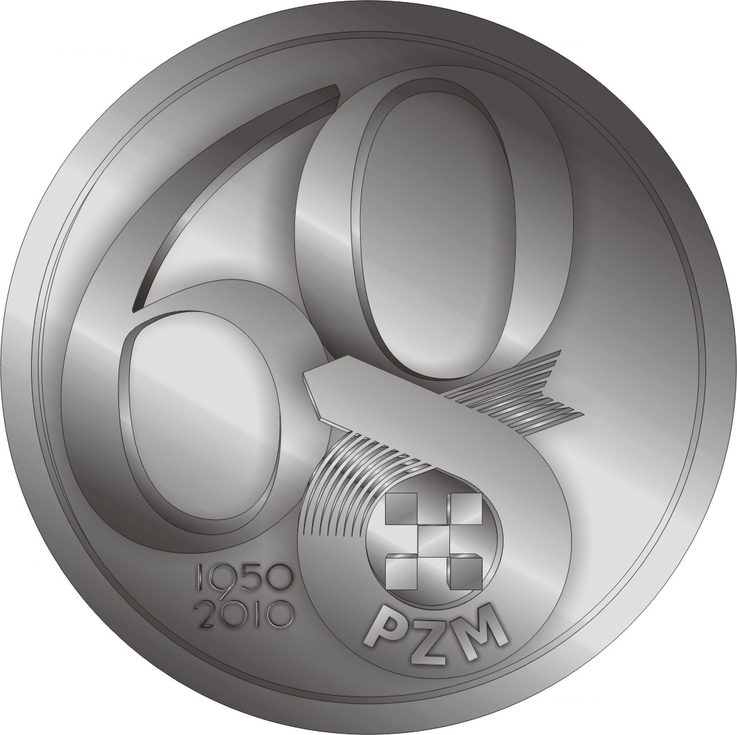
Polish
Navigation
Motorcar
Championship

Administration PZM at Opole and Opolskie Stowarzyszenie Automobilistów would wishes to invite to Navigation Rally KARLIK’2010, held on August 6th-8th, 2010, organised under the auspices of the General Commission of Popular Sports and Tourism PZM. Rounds Ist and IInd of Polish Navigation Motorcar Championship as well as the Ist and IInd round of Central Europe Cup will take place during KARLIK’2010. The rally will be held in accordance with the binding rules of Polish Navigation Motorcar Championship.

Rally Administration:
President of Opolskie Stowarzyszenie Automobilistów - Stefan Ostaficzuk
Rally Commander - Marek Pańka
Vice-Commander - Henryk Punt
Administrative Vice-Commander - Mirosława Babiak
Route Authors - Henryk Punt, Andrzej Morel
- Wojciech Kluk, Jarosław Praczyk
Assessment Commission - Irena Pańka

Route verification - Małgorzata Punt, Marek Pańka
Wojciech Czuczwara

Rally Base: Góra Św.Anny, Resort DOM PIELGRZYMA

Rally Programme:

6-08-2010 (Friday)
15:00 - 18:00 – competitors admissions (Góra Św.Anny)
18:45 - 19.30 - supper (Dom Pielgrzyma)
19:45 -KARLIK’2010, Opening Ceremony (Dom Pielgrzyma)
20.15 -24.15 - Ist round of Europe Cup, NIGHT stage

7-08-2010 (Saturday)
7:00 - Ith round unofficial scores
7:45 – 8:30 - breakfast

8:45 - 14.30 IInd round of Europe Cup, DAY stage
14:30 - 15:30 - lunch
16:00 - 18:00 - tourist part
18:30 - IVth round unofficial scores
20:00 - supper (Dom Pielgrzyma)
21:00 – Rally official scores, prize awarding (Dom Pielgrzyma)

8-08-2010 (Sunday)
8.30 - breakfast (Dom Pielgrzyma)
10.00 - Event’s end

Applications:

Participants should submit their applications before 27-08-2010
by sending their APPLICATON FORM to:

Opolskie Stowarzyszenie Automobilistów
45-231 Opole ul.Oleska 125a
POLAND

or by e-mail: osaopole@poczta.fm
For more information check: http://osaopole.fm.interia.pl/
A detailed Rally programme confirming participation will be sent to the applicants.

For detailed information call:
Stefan Ostaficzuk: +48 601 558 350
Marek Pańka +48 604 073 345
Jakub Żak +48 792 649 510 - speak english

President
of Opolskie Stowarzyszenie
Automobilistów

Stefan Ostaficzuk

