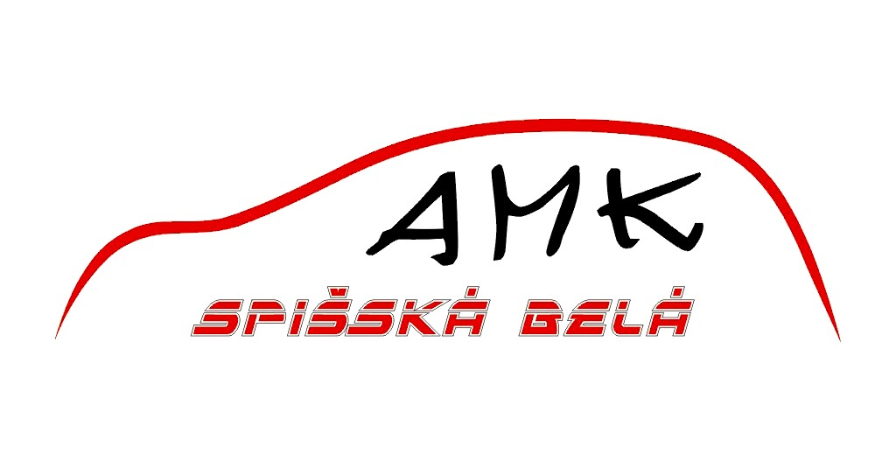

Automobilový klub
Továrenska 13, 059 01 Spišská Belá, tel.: 00421/52/4591422
SLOVAKIA
------------------------------------------------------------------------------------------
Spišská Belá, on march 31th, 2008
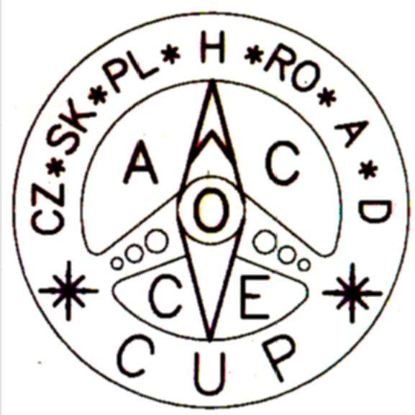

Dates of the 12.annual series of „ The Central Europen Cup “ :

1. round - night | 25.- 27.04.2008 | Praha | Czech Republic | CZ
2. round - day | 25.- 27.04.2008 | Praha | Czech Republic | CZ
3. round - night | 09.- 11.05.2008 | Opole | Poland | PL
4. round - day | 09.- 11.05.2008 | Opole | Poland | PL
5. round - night | 13.- 15.06.2008 | Poznan | Poland | PL
6. round - day | 13.- 15.06.2008 | Poznan | Poland | PL
7. round - night | 04.- 06.07.2008 | Pecs | Hungary | H
8. round - day | 04.- 06.07.2008 | Pecs | Hungary | H
9. round - night | 05.- 07.09.2008 | Baia Mare | Romania | RO
10. round - day | 05.- 07.09.2008 | Baia Mare | Romania | RO
11. round - night | 03.- 05.10.2008 | Spisska Bela | Slovakia | SK
12. round - day | 03.- 05.10.2008 | Spisska Bela | Slovakia | SK

Greeting to all friend of racing from

Ing. Peter Rusiňák

Ing. Peter Rusiňák, Rázusova 3287/2, bl.BEČVA, 058 01 Poprad, SLOVAKIA

Tel.: +421/52/7142812 - office, +421/52/7733503 - at home; mobil : +421904380744

e-mail : ruso660912@gmail.com
website : www.amkspisskabela.sk

Reglement of 12. annual series of “The Central European Cup“.

Season 2008

- In the series of automobile orientation championship “The Central European Cup“ can start nominated crews, which will get mastership points.

The organiser evaluate the double round after this manner :

- Orientation ride : Notes : BP = Bad Points, MP = Mastership Points

- crew will get mastership points every round particularly

Example :
1.round ( CZ-night ) - 1.place Crew1 638 BP 40 MP
2.place Crew2 760 BP 36 MP
3.place Crew3 940 BP 32 MP

2.round ( CZ-day ) - 1.place Crew3 545 BP 40 MP
2.place Crew2 650 BP 36 MP
3.place Crew1 980 BP 32 MP

- result crew in round = sum bad points from orientation ride and ride of skills

- ceremonious declaration of results – winner will be dedicated counts of BP for double round

Example : Notes BP = Bad Points, MP = Mastership Points

1.round ( CZ-night ) + 2.round ( CZ-day ) - 1.place Crew2 1410 BP
2.place Crew3 1485 BP
3.place Crew1 1618 BP

- declare 6 best crews in total evaluation for double round

Example : equal score BD – Orientation ride – better ride of skills :

Ride of skills

Time - BP Elements – BP

a) 1.round(CZ-night)- 1.place crew1 760 BP ( 1:01,42 min. =124 BP 0 BP ) 40 MP
2.place crew2 760 BP ( 1:03,87 min. =128 BP 0 BP ) 36 MP
3.place crew3 940 BP 32 MP

Ride of skills

Time - BP Elements – BP

b) 1.round(CZ-night)- 1.place Crew1 760 BP ( 1:01,42 min. =124 BP 0 BP ) 40 MP
2.place Crew2 760 BP ( 0:56,42 min. =114 BP 10 BP ) 36 MP
3.place Crew3 940 BP 32 MP

Ride of skills

Time - BP Elements – BP

c) 1.round(CZ-night)- 1.place Crew1 760 BP ( 1:01,42 min. =124 BP 0 BP ) 40 MP
2.place Crew2 760 BP ( 1:01,42 min. =124 BP 0 BP ) 40 MP
3.place Crew3 940 BP 32 MP
- Ride of skills :

- drivers will get mastership points every round particularly

Example :

1.round ( CZ-night ) - 1.place Driver1 138 BP 40 MP
2.place Driver2 260 BP 36 MP
3.place Driver3 440 BP 32 MP

2.round ( CZ-day ) - 1.place Driver3 45 BP 40 MP
2.place Driver2 150 BP 36 MP
3.place Driver1 480 BP 32 MP

- ceremonious declaration of results – winner will be dedicated counts of BP for double round

Example :

1.round ( CZ-night ) + 2.round ( CZ-day ) - 1.place Driver2 410 BP 2.place Driver3 485 BP
3.place Driver1 618 BP

- declare 3 best drivers in total evaluation for double round

Example : equal score BP – ride of skills : Time - BP Elements – BP

a) 1.round(CZ-night)- 1.place Driver1 124 BP ( 1:01,42 min. =124 BP 0 BP ) 40 MP
2.place Driver2 124 BP ( 0:56,64 min. =114 BP 10 BP ) 36 MP
3.place Driver3 168 BP 32 MP

Time - BP Elements – BP

b) 1.round(CZ-night)- 1.miesto Driver1 124 BP ( 1:01,42 min. =124 BP 0 BP ) 40 MP
1.miesto Driver2 124 BP ( 1:01,42 min. =124 BP 0 BP ) 40 MP
3.miesto Driver3 168 BP 32 MP

Mastership points:
1.place /40 points
2. /36
3. /32
4. /28
5. /25
6. /22
7. /19
8. /16
9. /14
- /12
- /10
- / 9
- / 8
- / 7
- / 6
- / 5
- / 4
- / 3
- / 2
- / 1

When there is the same number of points, the post will be determined after summary of points of championships in which both crews took part.

The organiser of every competition round of the „Central European Cup“ are asked to evaluate also the individual rides of skills. The cup´s points of every ride of skills you should add to every crew, similar to the total results and in the end of the season there will be an evaluation of the six best drivers with the highest amount of points reached in cups.
The evaluation of ride of skills is similar to the final results. (see the table No. 7)

- Three nominated crews from each country have food and accommodation settlement from organiser - these crews designate each country ( right of priority have crews from club organiser ). Every next of nominated crews of the series of “The Central European Cup“ will pay start-charge presented in prepositions. The organiser will define value of start-charge according to direct costs of crew - food and accommodation, maximum – 50 EUR/1 crew or 25 EUR/1 person.

- Schedule of rounds of 12. annual series of “The Central European Cup“, season 2008:

1. round - night | 25.- 27.04.2008 | Praha | Czech Republic | CZ
2. round - day | 25.- 27.04.2008 | Praha | Czech Republic | CZ
3. round - night | 09.- 11.05.2008 | Opole | Poland | PL
4. round - day | 09.- 11.05.2008 | Opole | Poland | PL
5. round - night | 13.- 15.06.2008 | Poznan | Poland | PL
6. round - day | 13.- 15.06.2008 | Poznan | Poland | PL
7. round - night | 04.- 06.07.2008 | Pecs | Hungary | H
8. round - day | 04.- 06.07.2008 | Pecs | Hungary | H
9. round - night | 05.- 07.09.2008 | Baia Mare | Romania | RO
10. round - day | 05.- 07.09.2008 | Baia Mare | Romania | RO
11. round - night | 03.- 05.10.2008 | Spisska Bela | Slovakia | SK
12. round - day | 03.- 05.10.2008 | Spisska Bela | Slovakia | SK

- Delivery time lag + ranking of delivery time lag in race :

One stage – maximum permissible delivery time lag – 45 minutes
Two stages – maximum permissible delivery time lag – 60 minutes,
from that in one stage maximum permissible delivery time lag – 45 minutes
Three stages and more – maximum permissible delivery time lag – 90 minutes,
from that in one stage maximum permissible delivery time lag – 45 minutes

Ranking of delivery time lag : 1 – 10 minute - per every begun minute 5 BP
11 – 20 minute - per every begun minute 10 BP
21 – 30 minute - per every begun minute 15 BP
31 – 60 minute - per every begun minute 20 BP
61 minute and more - bonus 10000 BP

Example : Two night stages – delivery time : 1.stage – 22 minutes 2.stage – 34 minutes
( max. 60minutes ) ranking : 180 TB 380 TB

Three day stages – delivery time : 1.stage – 14 minút , 2.stage - 45 minút, 3.stage – 7 minút
( max. 90minutes ) ranking 90 TB 600 TB 35 TB

Dve nočné etapy – meškanie : 1.stage – 12 minút 2.stage – 48 minút
( max. 60minutes ) ranking : 70 TB 10000 TB

Delivery time must be assigned for every round particularly. Night round particularly and day round particularly.
- Final results of 11. annual of the series of “The Central European Cup“, season 2007:

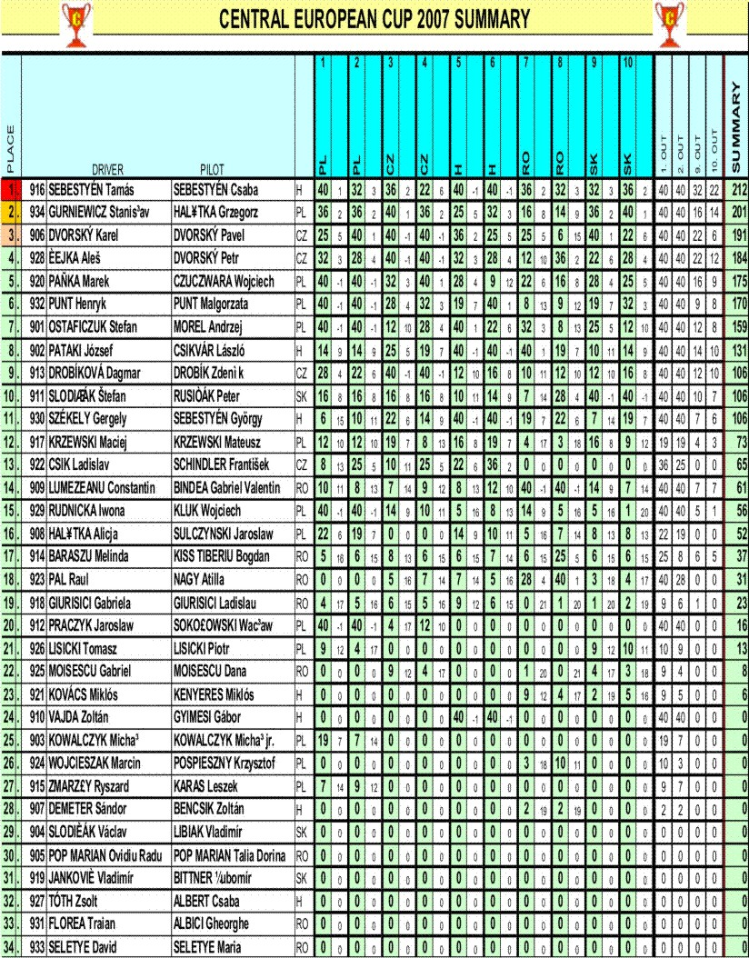

Final results of 11. annual of the series of “The Central European Cup“ - Ride of skills – season 2007 :

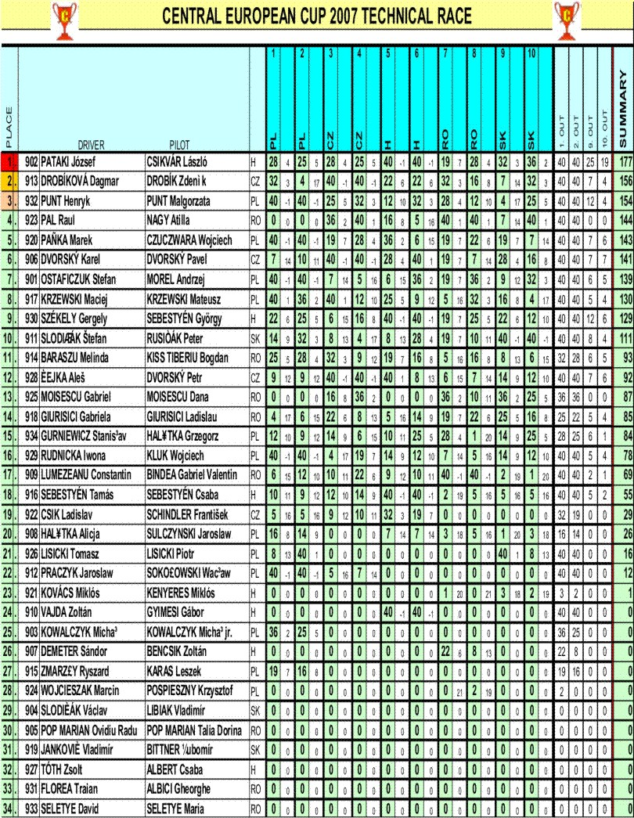

- List of nomination for 12. annual series of “The Central European Cup“, season 2008:

901. | PUCHALSKI Wojciech | MALICKA Anna | PL | Poznań
902. | VAJDA Zoltán | GYIMESI Gábor | H | Pécs
903. | PAŃKA Marek | PAŃKA Irena | PL | Opole
904. | SLODIČÁK Václav | LIBIAK Vladimír | SK | Spišská Belá
905. | GIURISICI Gabriela | GIURISICI Ladislau | RO | Timisoara
906. | ČEJKA Aleš | DVORSKÝ Petr | CZ | Tišnov
907. | SEBESTYÉN Tamás | SEBESTYÉN Csaba | H | Pécs
908. | GURNIEWICZ Stanisław | HALĄTKA Grzegorz | PL | Poznań
909. | ALBICI Gheorghe | POP MARIAN Ovidiu | RO | Baia Mare
910. | KOVÁCS Miklós | KENYERES Miklós | H | Kisújszállás
911. | JANKOVIČ Vladimír | BITTNER Ľubomír | SK | Košice
912. | KRZEWSKI Maciej | KRZEWSKI Mateusz | PL | Myslowice
913. | CSIK Ladislav | SCHINDLER František | CZ | Praha,Teplice n/M.
914. | MOISESCU Gabriel | MIHAILA Gheorghe | RO | Braila
915. | PRACZYK Jaroslaw | SOKOLOWSKI Waclaw | PL | Opole
916. | PATAKI Jozef | CSIKVÁR László | H | Pécs
917. | MICHALAK Małgorzata | MICHALAK Michal | PL | Poznań
918. | BARAZSU Melinda | KISS Tiberiu | RO | Baia Mare
919. | SLODIČÁK Štefan | RUSIŇÁK Peter | SK | Spišská Belá
920. | KLUK Iwona | KLUK Wojciech | PL | Opole
921. | TÓTH Zsolt | ALBERT Csaba | H | Pécs
922. | PAZDERKA Zdeněk | PAZDERKOVÁ Lucie | CZ | Brno
923. | JURCA Cornel | JURCA Adina | RO | Timisoara
924. | OSTAFICZUK Stefan | CZMIELEWSKI Marek | PL | Opole
925. | NETA Bogdan | PETRUT Simona | RO | Baia Mare
926. | JAWORSKI Rafał | JAWORSKA Monika | PL | Poznań
927. | DEMETER Sándor | DEMETERNÉ Julika | H | Kisújszállás
928. | DROBÍKOVÁ Dagmar | DROBÍK Zdeněk | CZ | Hlučín
929. | RAJ Agnieszka | MOREL Andrzej | PL | Opole
930. | SZÉKELY Gergely | SEBESTYÉN György | H | Pécs
931. | MIHAI Neculai | NEMTANU Valentin | RO | Braila
932. | HALĄTKA Alicja | RYBAK Grzegorz | PL | Poznań
933. | LUMEZEANU Constantin | BINDEA Gabriel | RO | Baia Mare
934. | PUNT Henryk | PUNT Małgorzata | PL | Opole

The organiser of every round is responsible for keeping assigned start-positions because of a continuous and total score of every crew.

- The organiser should keep the valid rules for “The Central European Cup“ by building the track, the most important is to avoid using text instructions for itinerar. This itinerar should be understandable and unambiguous for every crew from different country, that there is no language barrier.

- The winner of 12. annual series of “The Central European Cup“ is the crew with highest amount of mastership points. To the total score we add six rounds run over. There is cancelled two the best and two the worst round of 12. annual series of “The Central European Cup“.

Example of result score: Notes – points = mastership points

- 1.round - 3.place/32 points
2.round - 6.place/22 points
3.round - 5.place/25 points
4.round - 7.place/19 points – the worst cancelled round
5.round - 2.place/36 points – the best cancelled round
6.round - 3.place/32 points
7.round - 6.place/22 points 32+22+25+32+22+25+22+25=205 points - the total result
8.round - 5.place/25 points
9.round - 7.place/19 points – the worst cancelled round
10.round - 2.place/36 points – the best cancelled round
11.round - 6.place/22 points
12.round - 5.place/25 points

- 1.round - the organiser/40 points – the best cancelled round
2.round - the organiser/40 points – the best cancelled round
3.round - 6.place/22 points
4.round - 5.place/25 points
5.round - 7.place/19 points – the worst cancelled round
6.round - 2.place/36 points
7.round - 5.place/25 points
8.round - 7.place/19 points – the worst cancelled round
9.round - 2.place/36 points
10.round - 2.place/36 points
11.round - 6.place/22 points
12.round - 5.place/25 points 22+25+36+25+36+36+22+25=227 points - the total result

- 1.round - the organiser/40 points – the best cancelled round
2.round - the organiser/40 points – the best cancelled round
3.round - 6.place/22 points
4.round - 5.place/25 points
5.round - absence/ 0 points – the worst cancelled round
6.round - absence/ 0 points – the worst cancelled round
7.round - 5.place/25 points
8.round - 7.place/19 points
9.round - 2.place/32 points
10.round - 2.place/32 points
11.round - 6.place/22 points
12.round - 5.place/25 points 22+25+25+19+32+32+22+25=202 points - the total result

- 1.round - the organiser/40 points – the best cancelled round
2.round - the organiser/40 points – the best cancelled round
3.round - 6.place/22 points
4.round - 5.place/25 points
5.round - absence/ 0 points – the worst cancelled round
6.round - absence/ 0 points – the worst cancelled round
7.round - 5.place/25 points
8.round - 7.place/19 points
9.round - absence/ 0 points
10.round - absence/ 0 points
11.round - 6.place/22 points
12.round - 5.place/25 points 22+25+25+19+0+0+22+25=138 points - the total result

- The organizer is compulsory to publish the right run of the round + model report
driving + provide for a duplicate exact gate-way track for everybody accessary landscape

- The cups for 6 best crews in total evaluation of 12. annual series of “The Central European Cup“ , season 2008 and the cups for 6 best drivers with the highest amount of points , will provite Poland ( Opole, Poznań ).

- The schedule of 13. annual series of “The Central European Cup“ – season 2009 will be made up and agreed during the sitting of representatives participated countries 04.10.2008 in “SANATÓRIUM“ in Tatranská Kotlina, Slovakia

